🧠 Page Replacement Algorithm
A Page Replacement Algorithm is used in Operating Systems when RAM (main memory) is full and a new page needs to be loaded.
The OS must decide which page to remove (replace) from memory.
📌 Goal:
- Reduce page faults
- Improve system performance

✅ FIFO Page Replacement Algorithm (C)
#include <stdio.h>

int main() {
int pages[50], frames[10];
int n, frame_size;
int page_faults = 0;
int i, j, k = 0;
int found;

printf("Enter number of pages: ");
scanf("%d", &n);

printf("Enter page reference string:\n");
for (i = 0; i < n; i++) {
scanf("%d", &pages[i]);
}

printf("Enter number of frames: ");
scanf("%d", &frame_size);

// Initialize frames
for (i = 0; i < frame_size; i++)
frames[i] = -1;

printf("\nPage\tFrames\n");

for (i = 0; i < n; i++) {
found = 0;

for (j = 0; j < frame_size; j++) {
if (frames[j] == pages[i]) {
found = 1;
break;
}
}

if (!found) {
frames[k] = pages[i];
k = (k + 1) % frame_size;
page_faults++;
}

printf("%d\t", pages[i]);
for (j = 0; j < frame_size; j++) {
if (frames[j] != -1)
printf("%d ", frames[j]);
else
printf("- ");
}
printf("\n");
}

printf("\nTotal Page Faults: %d\n", page_faults);
return 0;
}

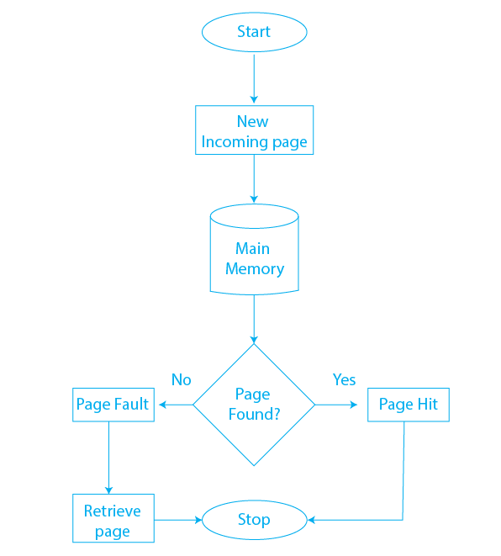
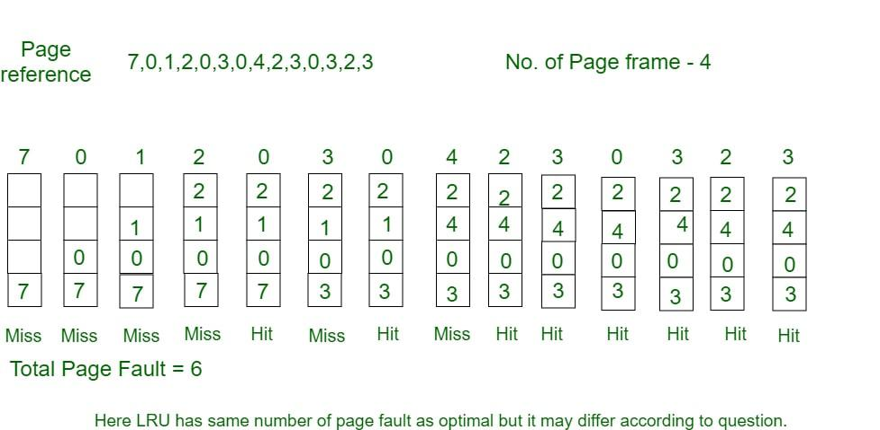
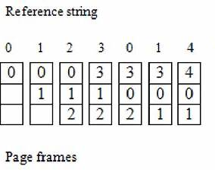
FIFO = First In, First Out
➡️ The oldest page in memory is removed first.
🔹 How it works:
- Pages are loaded into memory in order
- When memory is full:
  - Remove the page that entered first

🔹 Example:
Page reference string:
1 2 3 4 1 5
Frames = 3
Step | Pages in Memory
1 | 1
2 | 1 2
3 | 1 2 3
4 | 2 3 4 (1 removed)
1 | 3 4 1 (2 removed)
5 | 4 1 5 (3 removed)
✅ Advantages:
- Very simple
- Easy to implement
❌ Disadvantages:
- May remove important pages
- Suffers from Belady’s Anomaly

💽 Disk Scheduling Algorithm
A Disk Scheduling Algorithm decides which disk request to serve next when multiple requests are waiting.
📌 Goal:
- Minimize seek time
- Improve disk performance

✅ FCFS Disk Scheduling Algorithm (C)
#include <stdio.h>
#include <stdlib.h>

int main() {
int requests[50];
int n, head;
int total_seek_time = 0;
int i;

printf("Enter number of disk requests: ");
scanf("%d", &n);

printf("Enter disk request queue:\n");
for (i = 0; i < n; i++) {
scanf("%d", &requests[i]);
}

printf("Enter initial head position: ");
scanf("%d", &head);

printf("\nHead Movement:\n");
for (i = 0; i < n; i++) {
printf("%d -> %d\n", head, requests[i]);
total_seek_time += abs(requests[i] - head);
head = requests[i];
}

printf("\nTotal Seek Time: %d\n", total_seek_time);
return 0;
}

🚀 FCFS Disk Scheduling Algorithm
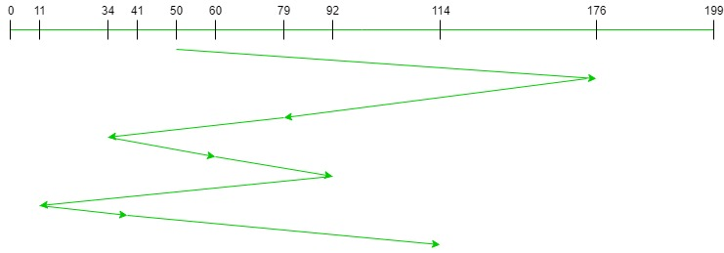

FCFS = First Come, First Served
➡️ Disk requests are handled in the order they arrive
🔹 How it works:
- No reordering of requests
- Serve requests one by one
🔹 Example:
Request Queue:
98, 183, 37, 122, 14, 124
Initial Head Position = 53
Head movement:
53 → 98 → 183 → 37 → 122 → 14 → 124
✅ Advantages:
- Simple
- No starvation
❌ Disadvantages:
- High seek time
- Poor performance for large queues

📝 Quick Exam Summary Table
Topic | Key Idea
Page Replacement | Replace pages when RAM is full
FIFO Page | Oldest page removed
Disk Scheduling | Decide next disk request
FCFS Disk | Requests served in arrival order

